Undergraduate Lab Report of Jinan University
Course Title Computer Networks Lab Evaluation
Lab Name Ethernet Frame
Lab Address N117 Instructor Dr. CUI Lin (崔林)
Student Name 蒋云翔 Student No 2022102330
College International School
Department Major CST
Date 2024 / 10 / 26
- Introduction
- Objective
• Understand the details of Ethernet frames, e.g., frame format.
• Understand functions of Ethernet address (i.e., MAC address), e.g., unicast,
broadcast and multicast address.
• Know LLC header format.
- Experiment Principle
1. The OSI model and the TCP/IP protocol suite
Before we start our lab experiment, the concept of OSI model and the TCP/IP model are a must for us to get good command of.
The OSI model, or the Open Systems Interconnection Reference Model, is a conceptual model that standardizes the communication processes between different computer systems or network devices. It was proposed by the International Organization for Standardization (ISO) in 1984 to provide a common framework for network communication between devices from different manufacturers.
The OSI model is divided into seven layers, each with its specific functions and protocols:
- Physical Layer: Responsible for transmitting raw bit streams over physical media, involving electrical signals, light signals, etc.
- Data Link Layer: Ensures that the data transmitted by the physical layer is error-free and performs error detection and correction.
- Network Layer: Responsible for the transmission and routing of data packets from the source to the destination.
- Transport Layer: Provides end-to-end data transfer services to ensure the integrity and reliability of the data.
- Session Layer: Manages and controls the session connections between applications.
- Presentation Layer: Ensures that the information sent by the application layer of one system can be read by the application layer of another system, responsible for data format conversion, data encryption, and compression.
- Application Layer: Provides network services for software applications, such as HTTP, FTP, SMTP, etc.

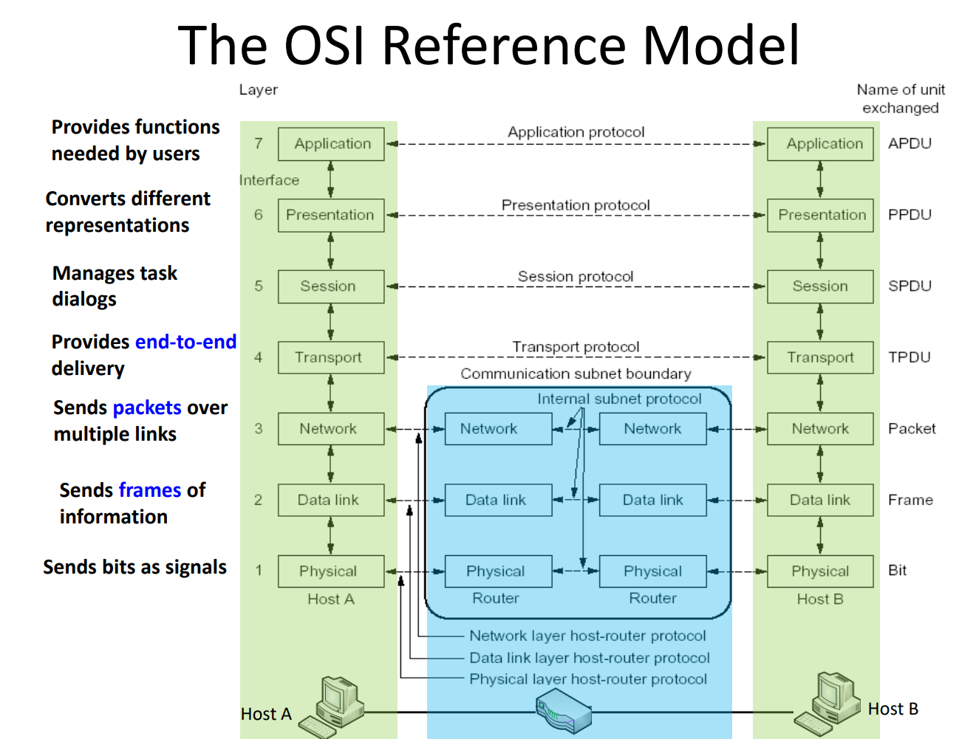
Figure1. The OSI Reference Model

The TCP/IP protocol, or Transmission Control Protocol/Internet Protocol, is a suite of core communication protocols used on the Internet. It defines how electronic devices exchange data over a network and forms the foundation of the internet's infrastructure.
The TCP/IP model consists of four layers, each responsible for different tasks in network communication:
- Application Layer: Provides network services for software applications, such as HTTP (web browsing), FTP (file transfer), SMTP (email sending), etc.
- Transport Layer: Ensures the integrity and reliability of data, with TCP (Transmission Control Protocol) and UDP (User Datagram Protocol) being the main protocols at this layer.
- Internet Layer: Responsible for the transmission and routing of data packets from the source to the destination, with IP (Internet Protocol) being the primary protocol.
- Network Interface Layer: Responsible for the actual transmission of data over physical network media, involving hardware and software details.
The design goal of the TCP/IP protocol is to achieve network interoperability, allowing devices produced by different manufacturers to communicate with each other. It supports a variety of network types, including Local Area Networks (LAN), Wide Area Networks (WAN), and wireless networks.
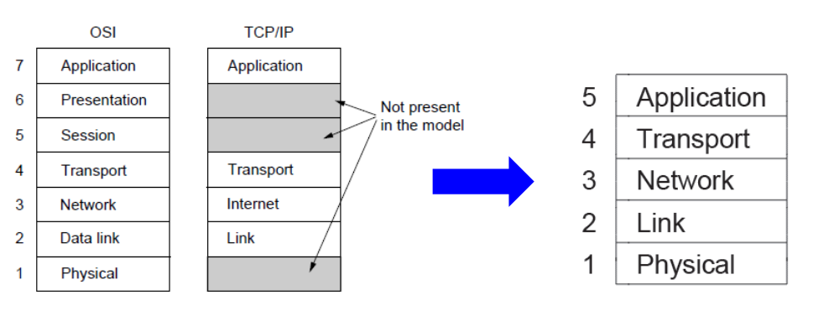
Figure2. TCP/IP protocol

2. IEEE802 reference model
The IEEE 802 reference model is a framework developed by the IEEE 802 standards committee, focusing on the standardization of Local Area Networks (LANs), Metropolitan Area Networks (MANs), and Personal Area Networks (PANs). This model primarily addresses the bottom two layers of the OSI model, namely the Physical Layer and the Data Link Layer. In practice, IEEE 802 further divides the OSI Data Link Layer into two sublayers: the Logical Link Control (LLC) and the Media Access Control (MAC).
In the IEEE 802 reference model:
- Physical Layer: It defines the electrical, mechanical, functional, and procedural characteristics of the transmission medium and its interfaces, responsible for transmitting raw bit streams over the physical medium.
- MAC Sublayer: It deals with the contention issues among various stations in the local area network for communication media, providing error-free communication on top of the Physical Layer. The main functions of the MAC sublayer include framing data, error detection, and addressing.
- LLC Sublayer: It provides standard OSI Data Link Layer services, shielding the specific implementation of the MAC sublayer, turning it into a uniform LLC interface, thereby providing consistent services to the Network Layer. The main functions of the LLC sublayer include establishing and releasing logical connections at the Data Link Layer, providing an interface to the higher layers, and error control.

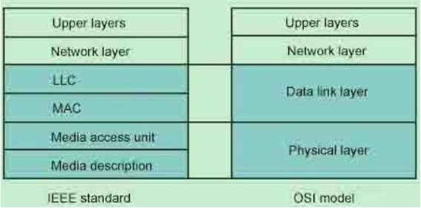
Firgure3. IEEE TCP/IP and OSI reference model

3. Ethernet physical address
Ethernet physical address, also known as MAC address (Media Access Control Address), is a unique identifier assigned to network devices operating on the Ethernet-based network. It is used to recognize the device's location in the network and is typically found on the device's network interface card (NIC) or other physical-layer networking devices.
MAC addresses are structured as a 6-byte (48-bit) address, usually represented as a 12-digit hexadecimal number. The first three bytes (24 bits) are known as the Organizationally Unique Identifier (OUI), which is assigned by the IEEE to the manufacturer of the network device. This part ensures that the manufacturer's identity is included in the address. The last three bytes (24 bits) are used by the manufacturer to uniquely identify each device they produce, making the entire MAC address unique globally.
The MAC address is encoded in the device's hardware and is managed by the manufacturer to ensure its uniqueness across all devices. It is used at the data link layer of the OSI model for communication within a local network. Devices like switches and routers use MAC addresses to forward frames to the correct destination on the network.

4. Ethernet access mode
Here's how the CSMA/CD protocol works:
- Carrier Sense: Before transmitting data, a device first checks whether another device is already transmitting on the medium. If the medium is busy (i.e., there is a carrier signal), the device waits until the medium is idle.
- Multiple Access: If the medium is idle, the device can begin transmitting data. However, because multiple devices might detect the medium as idle at the same time and start transmitting, this can lead to a collision.
- Collision Detection: When two or more devices transmit simultaneously, their signals interfere with each other on the medium, causing a collision. Devices must be able to detect this collision. While transmitting, a device continuously listens to the medium to detect if a collision occurs.
- Collision Handling: If a collision is detected, the device immediately stops transmitting and sends a special signal (Jam signal) to ensure that all devices on the network are aware of the collision. Then, the device waits for a random time interval before attempting to transmit again. This process is called the Exponential Backoff Algorithm, which reduces the likelihood of another collision.
The advantage of the CSMA/CD protocol is that it is simple and easy to implement, suitable for low-load networks. However, as network load increases, the probability of collisions also increases, leading to decreased network efficiency. In high-load networks, CSMA/CD can cause a lot of data retransmissions, thereby degrading network performance.
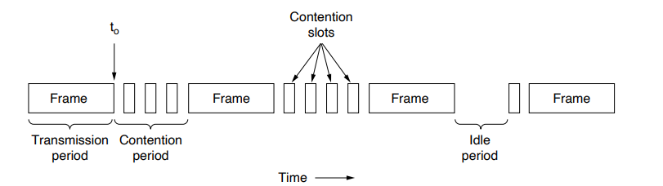
Figure4. CSMA/CD protocol

5. Ethernet frame format
(1)MAC Frame Format
The MAC frame is the unit of data transmitted at the Data Link layer. The MAC frame format typically consists of the following parts:
- Preamble: A sequence of bits used to synchronize the receiver's clock and prepare it to receive the frame.
- Start of Frame Delimiter (SFD): Indicates the beginning of the frame.
- Destination Address (DA): The MAC address of the recipient of the frame.
- Source Address (SA): The MAC address of the sender of the frame.
- Length/Type: Indicates the length of the data field or the type of protocol encapsulated in the data.
- Data: The actual data payload being transmitted.
- Frame Check Sequence (FCS): A cyclic redundancy check (CRC) value calculated from the frame data for error detection.
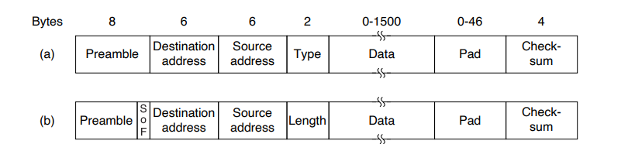
In IEEE 802.11 wireless networks, the MAC frame includes additional fields such as the Frame Control Field, Duration/ID Field, Address Fields, and Sequence Control Field
Figure5. MAC frame format

(2)LLC Frame Format
The LLC frame format is the logical link control part of the Data Link layer, which sits above the MAC layer. The LLC frame format includes the following parts:
- DSAP (Destination Service Access Point): Identifies a specific service at the destination device.
- SSAP (Source Service Access Point): Identifies a specific service at the source device.
- Control Field: Used to control LLC layer operations, such as the type of frame and transmission control information.
- Information Field: The actual data being transmitted.

Figure6. LLC frame format
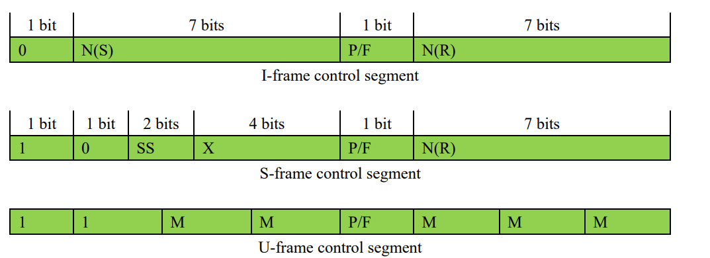
Figure7. Control fields of three types of LLC
1. N(S): send number
2. N(R): received number
3. SS: supervisory function bit, 00 means ready to receive (RR); 10 means not ready
to receive(RNR); 01 means reject to receive (REJ)
4. M: modify function bit
5. X: save, set to be 0
6. P/F: Poll/Final bit. Ask LLC PDU to transmit/ respond LLC PDU transmission.

(3) Relationship between LLC-PDU and neighbor layer PDU
- LLC-PDU:
  - The LLC layer is part of the Data Link layer in the OSI model, and it operates above the MAC layer. The LLC-PDU includes the data that is being transmitted, along with LLC-specific control information. The LLC layer is responsible for protocol multiplexing, flow control, and error control.
  - LLC-PDUs are typically encapsulated with LLC headers that include the DSAP (Destination Service Access Point) and SSAP (Source Service Access Point) addresses, which are logical addresses used to identify different services within the LLC layer.
- MAC-PDU:
  - The MAC layer is responsible for controlling the communication medium and handling the actual transmission of data across the physical network. The MAC-PDU includes the LLC-PDU as its payload and adds MAC headers and trailers for error checking and frame synchronization.
  - The MAC header contains the destination and source MAC addresses, which are the physical addresses of the devices on the network. The MAC layer ensures that the data is transmitted reliably over the physical medium.
The relationship between LLC-PDU and MAC-PDU is that the LLC-PDU is passed down to the MAC layer, where it is encapsulated within a MAC frame. The MAC layer then adds the necessary headers and trailers to form a MAC-PDU, which is ready for transmission over the physical medium. This process is known as encapsulation, where each layer adds its own header information to the data unit as it moves down the protocol stack.
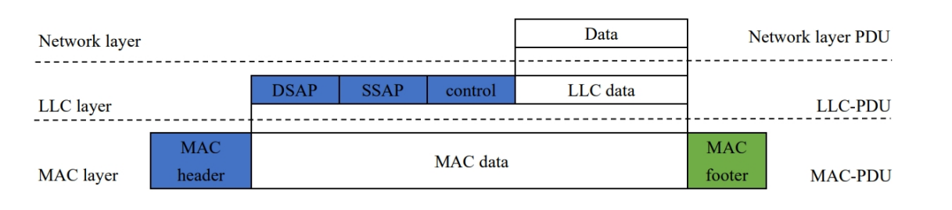
Figure8. Encapsulation of LLC PDU

- Lab Environment
This experiment is accomplished at home using wireless network with my laptop.

- Computer name:
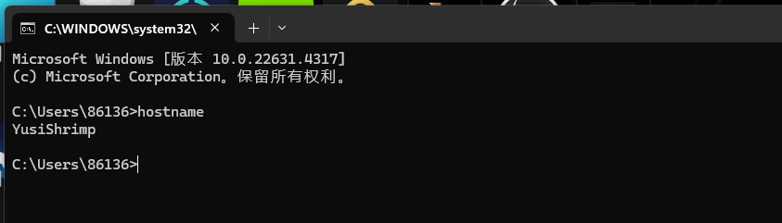
Figure9. cmd window that shows host name

- Detailed information:
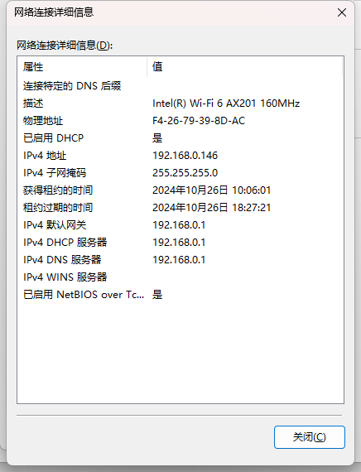
Figure10. Detailed information of network
- Experiment Steps and Results
- Task 1: Capture a Trace
1. Experiment Steps
- Step 1: Select a remote web server or any other publicly accessible Internet host, and utilize the ping command to send some echo request messages to it, verifying that it responds.
- Step 2: Execute the ping command again, but this time, initiate Wireshark to capture Ethernet frames while ensuring that the "Enable MAC name resolution" option is selected. Consequently, Wireshark will also record the packets being sent by the ping command.
- Step 3: Once the ping command has finished, navigate back to Wireshark and cease the capture. We now have a brief trace. As we know the IP address of the web server shown on the cmd window, we can set a filter to capture the response packet by using “ip.addr = xxx.xxx.xxx.xxx” (compared to the Tips from the lab notebook given by Prof. Cui, You set “icmp” as a filter but I set ip.addr as a filter here)

2. Results
(1) Results of using ping command
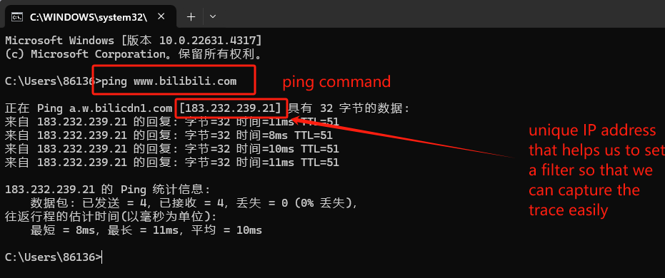
Figure 11. cmd window showing ping command

- Results of Wireshark’s receiving packet

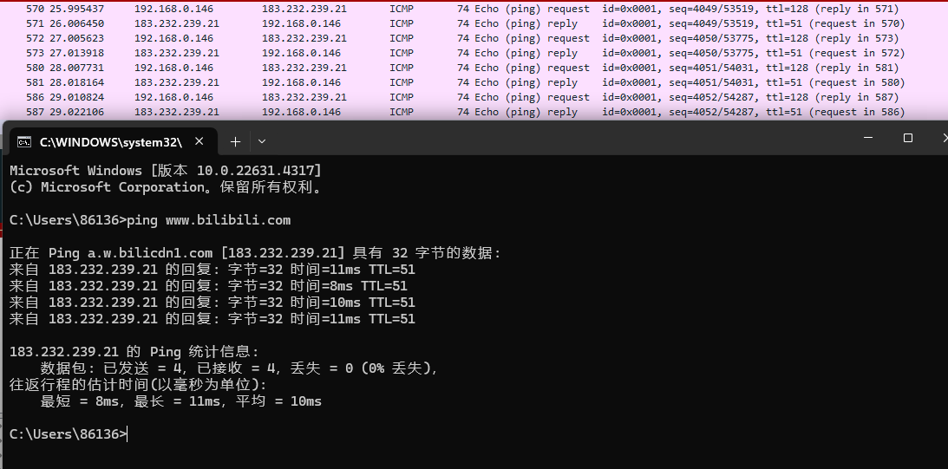
Figure 12. Wireshark receiving echo packet

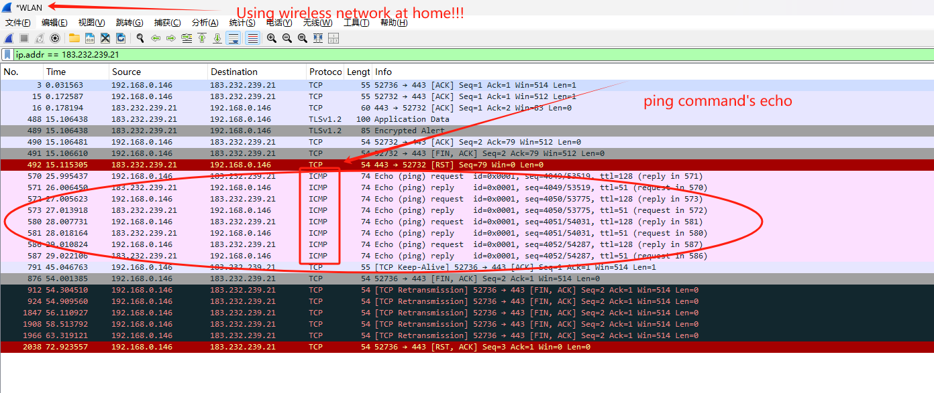
Figure13. The same as figure12.

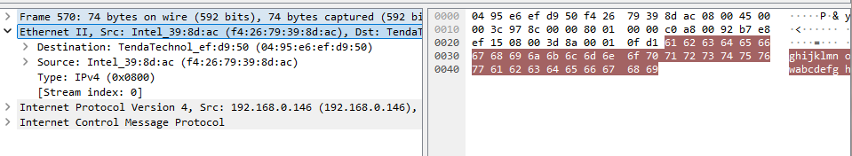
Figure14. Detailed information about Ethernet frame

- Task2: Inspect the Trace and Ethernet Frame Structure
- Experiment steps:
- Just figure out and understand the core information of figure 14. Detailed information about Ethernet frame or figure15. and then answer the following questions in the notebook.
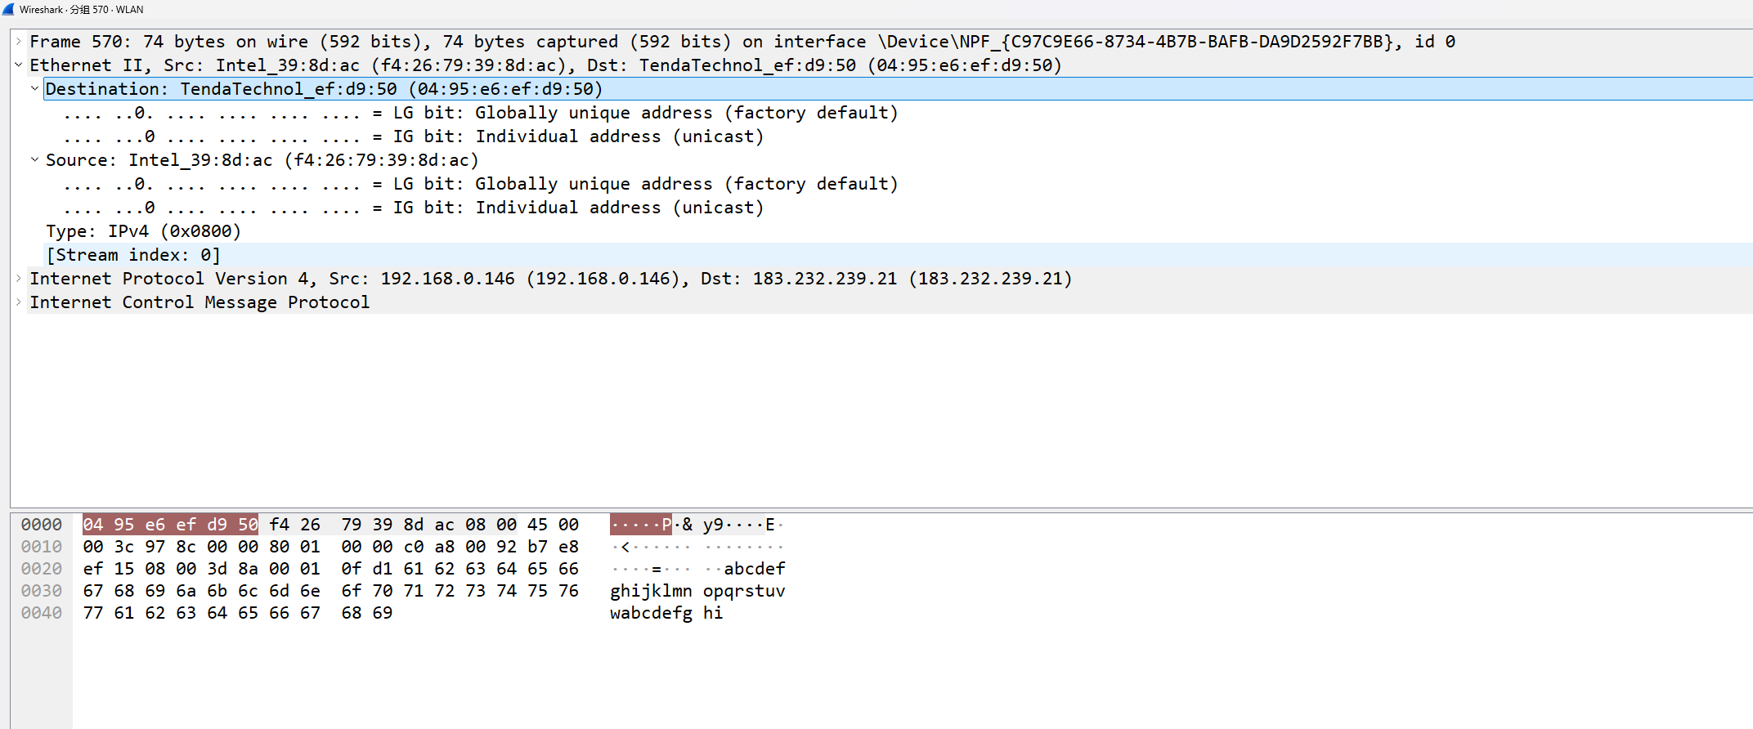
Figure 15. Detailed information about Ethernet frame

- Answering the given questions
Q1: Explain the fields of Ethernet frame you see in the trace.
A1: It is an Ethernet II frame, the standard format for Ethernet frame. It contains some significant information. ①Destination address:04:95:e6:ef:d9:50, which indicates the intended device that receives the data ②Source address: f4:26:79:39:8d:ac, which signifies the device sending the ping command ③Frame type: Using 2 bytes to show its version is IPv4.

Q2: Compare these fields with the Ethernet frame format introduced in the textbook (e.g., any fields that are missing in your trace? Their usage?).
A2: We know that a standard Ethernet frame contains the following seven part: Preamble, Start Frame Delimiter, Destination Address, Source Address, Length/Type, Data, CRC. But the packet captured by Wireshark only contains some of them: Destination Address, Source Address and type. The remaining parts have its own usage: Preamble is a sequence of bits used to synchronize the receiver's clock and prepare it to receive the frame. Start Frame Delimiter signals the beginning of the frame. The SFD warns the station or stations that this is the last chance for synchronization. The last 2 bits is 11 and alerts the receiver that the next field is the destination address. CRC is the last field contains error detection information, using CRC-32. It detects all contents except for preamble, SFD and CRC.

Q3: What is the length of captured frames? Explain why does Ethernet frame have the minimum length requirement.
A3:The length of the captured frames is 74 bytes in figure14/15. The range of Ethernet frame is 64-1518 bytes. Below is the reasons that Ethernet frame have the minimum length requirement.
- Collision Detection: Ethernet was originally designed to work over a shared medium. For half-duplex Ethernet, which cannot detect collisions while transmitting, the minimum frame size ensures that a signal can propagate over the longest distance between two stations in a segment, allow collision detection, and propagate the jamming signal back to the sender while it is still transmitting. This is because the minimum frame size is set to be at least twice the propagation delay of the medium, allowing time for a collision to be detected and the appropriate signals to be sent
- Network Efficiency: If frames were shorter than 64 bytes, the overhead of sending them would be relatively high, leading to network inefficiency. The minimum size ensures that there is enough data to be sent to make the transmission worthwhile, thus optimizing network performance.
- Protocol Overhead: The Ethernet frame format includes fields such as the destination and source MAC addresses, the type or length field, and the frame check sequence (FCS), which total 18 bytes. To meet the minimum frame size requirement, the payload must be at least 46 bytes. If the actual data is smaller than 46 bytes, it must be padded to meet this requirement. This padding ensures that the frame is not discarded due to being under the minimum size and also allows for error detection through the FCS

- Task 3: Scope of Ethernet Addresses
- Draw a figure
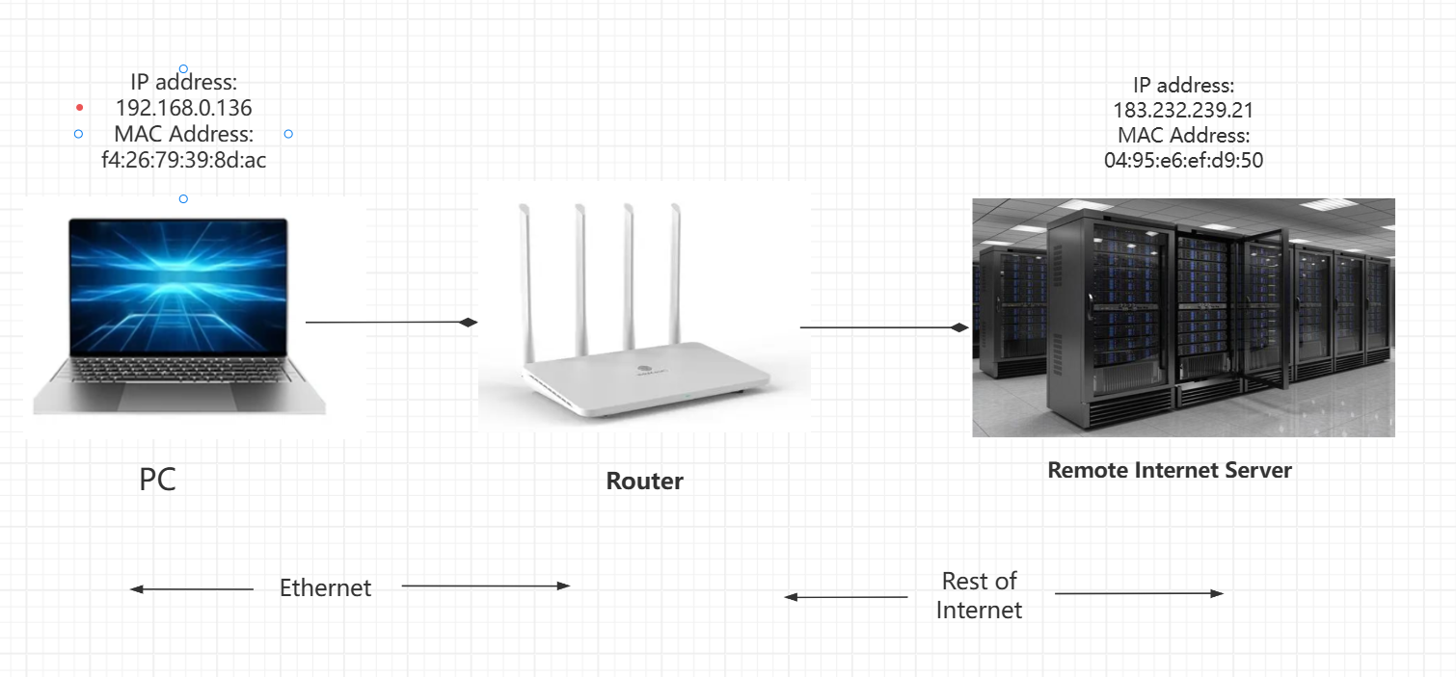
Figure16. The relative positions

- Answer the question
Q1: Which layer in TCP/IP model does MAC address apply to?
A1: The MAC address applies to the Link Layer of the TCP/IP model.

- Task 4: Broadcast and Multicast Frames
(1) Experiment Steps
- Step 1: Start a capture in Wireshark for broadcast and multicast Ethernet frames with a filter of “eth.dst[0]& 1” to capture both broadcast and multicast frames, wait up to 30 seconds (or more) to record background traffic, and then stop the capture.
- Step 2: Examine the multicast and broadcast packets captured, checking the details of the source and destination Ethernet addresses
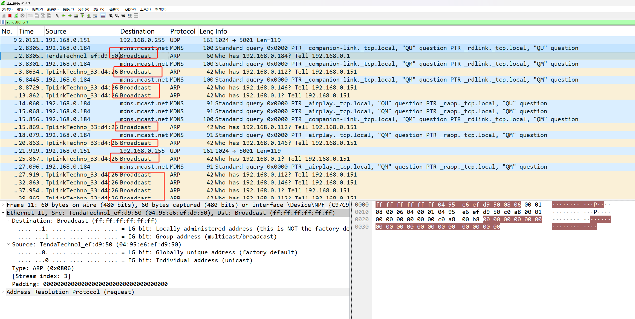
Figure17. Capture the Broadcast frame
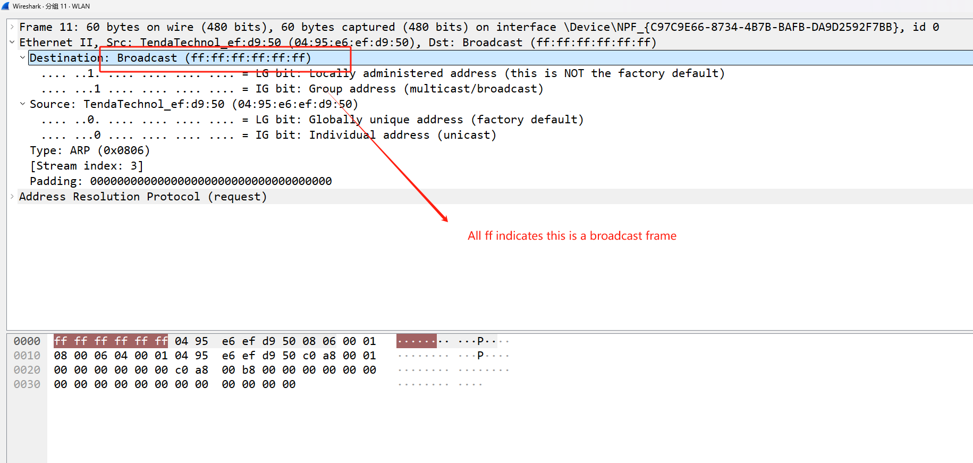
Figure18. Detailed information of broadcast frame

(2) Answer the questions
Q1: What is the broadcast Ethernet address?
A1: The broadcast Ethernet address is a MAC address that are all ones. It is represented as: ff:ff:ff:ff:ff:ff. All devices on the local network segment receive and process the frame when an Ethernet frame uses this address as its destination address,

Q2: Which bit of the Ethernet address is used to determine whether it is unicast or multicast/broadcast?
A2: In an Ethernet address (MAC address), the least significant bit of the first octet is used to determine whether the address is unicast or multicast/broadcast. If the least significant bit of the first octet is 0, then the address is a unicast address, meaning it is intended for a single specific recipient. If the least significant bit of the first octet is 1, then the address is a multicast/broadcast address.

Q3: What is the meaning of filter “eth.dst[0] & 1”?
A3: The filter expression "eth.dst[0] & 1" in Wireshark checks the least significant bit (LSB) of the first byte of the destination MAC address in an Ethernet frame. The "&" operator is a bitwise AND operation. If the result of this operation is 1, it means the LSB of the first byte of the destination MAC address is 1, indicating that the frame is a multicast frame.

Q4: If we use a filter “(eth.dst[0]&1) && !eth.dst==ff:ff:ff:ff:ff:ff”, what packets will be captured?
A4: The filter expression "(eth.dst[0]&1) && !eth.dst==ff:ff:ff:ff:ff:ff" in Wireshark captures packets that meet two conditions:
- The least significant bit (LSB) of the first byte of the destination MAC address is 1, indicating that the frame is a multicast frame.
- The destination MAC address is not the broadcast address ff:ff:ff:ff:ff:ff.
So, this filter will capture all multicast packets that are not broadcast packets.

- Task 5: LLC Header (IEEE 802.3)
(Tips: I accomplish this task at home and using wireless network, so I use the packet given by the course website!!!!!!)
- Experiment Results:
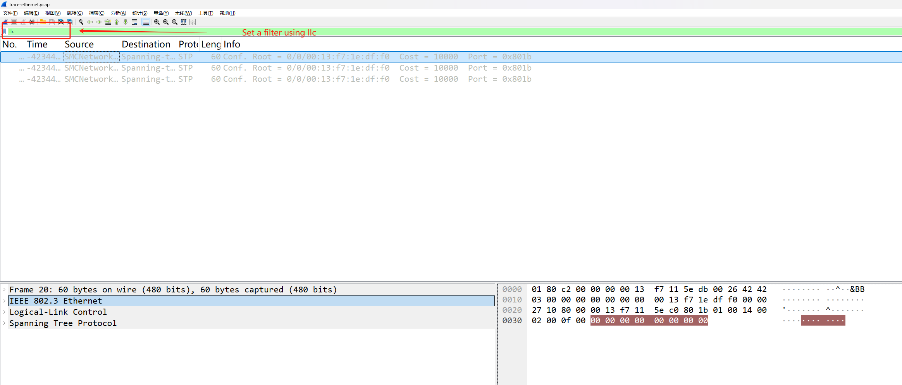
Figure19. Using llc filter to capture specific frame

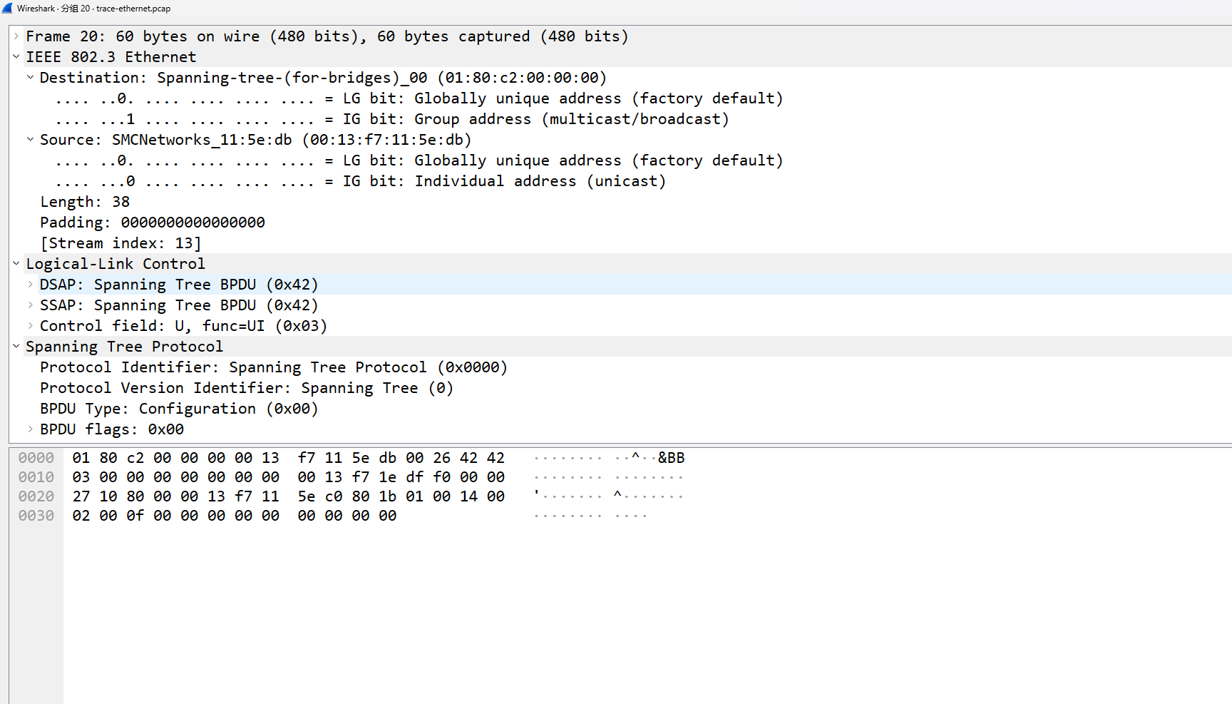
Figure20. Detailed information about IEEE 802.3 frame

- Answer the questions
Q1: What is the format of LLC header?
A1: The LLC header format is as follows:
- Destination Service Access Point (DSAP): 8 bits - This field specifies the address of the service access point (SAP) to which the frame is being sent. In the context of Ethernet, this is often set to AA (in hexadecimal) for standard Ethernet frames.
- Source Service Access Point (SSAP): 8 bits - This field specifies the address of the SAP from which the frame is being sent.
- Control (CTRL): 8 bits - This field is used to control the flow and management of the LLC layer. It indicates the type of LLC frame and the commands or responses it carries.

Q2: How long are the combined IEEE 802.3 and LLC headers compared to the DIX Ethernet headers?
A2: The combined IEEE 802.3 and LLC headers are longer than the DIX Ethernet headers. The IEEE 802.3 header is 14 bytes, which includes a 6-byte destination address, a 6-byte source address, and a 2-byte length/type field. The LLC header adds another 3 bytes, consisting of a 1-byte DSAP, a 1-byte SSAP, and a 1-byte control field. Therefore, the total length of the combined headers is 17 bytes. In contrast, the DIX Ethernet header only includes the 14 bytes of the IEEE 802.3 standard and does not have the additional 3 bytes of the LLC header.

Q3: How does the receiving computer know whether the frame is DIX Ethernet or IEEE 802.3?
A3: The receiving computer determines whether a frame is DIX Ethernet or IEEE 802.3 by examining the type/length field of the Ethernet frame. The type/length field is a 2-byte field that serves different purposes in these two frame formats:
- In DIX Ethernet frames, the type field identifies the upper-layer protocol.
- In IEEE 802.3 frames, the length field indicates the length of the data field.

Q4: If IEEE 802.3 frame has no Type field, how is the next higher layer determined? Use Wireshark to look for the demultiplexing key.
A4: IEEE 802.3 adds LLC header immediately after IEEE 802.3 header to pass on to the next layer agreement. LLC uses a single initial byte, called DSAP (Target Service Access Point), instead of The two bytes of the Type field.

- Others
- Answer the questions
Q1: Why IEEE 802 standard divides the data link layer into MAC sub-layer and LLC sub-layer?
A1:
Clear Division of Labor: The MAC sub-layer takes care of how data is sent and received, while the LLC sub-layer decides which upper-layer protocol the data should be sent to.
Flexibility: This division allows different network technologies, like Ethernet and Token Ring, to coexist. They can use the same LLC sub-layer but have different implementations in the MAC sub-layer.
Ease of Management: Separating these two sub-layers makes it easier to manage and expand networks. For example, you can change how networks are physically connected without changing the upper-layer protocols.
Support for Multiple Protocols: The LLC sub-layer can support various network-layer protocols, allowing different types of data to be transmitted over the same network.

Q2: What is the broadcast range (or scope) of a broadcast Ethernet frame?
A2: The broadcast range, or scope, of a broadcast Ethernet frame is typically limited to the local network segment. This is because most routers are configured by default not to forward broadcast frames to prevent network congestion and to maintain security boundaries. Additionally, in complex networks with multiple Virtual Local Area Networks (VLANs) or subnets, broadcast frames are confined to the specific segment from which they originate, thus keeping the scope of impact controlled.

- Something more I learned
1)Reasons for the Ethernet frame have maximum length requirement:
- Avoid a single host occupying the channel for a long time: If there is no upper limit on the length of frames, then one host may send a very long frame, which will cause other hosts to be unable to access the channel during frame transmission, thereby reducing the utilization and fairness of the network.
- Prevent buffer overflow: If the frame length is too long, it may exceed the buffer size of the receiving device, resulting in data loss or buffer overflow, which affects the stability and reliability of the network.
- Compatibility and historical reasons: The maximum length of Ethernet frames was also limited by early networking devices and protocols. For example, an earlier Ethernet standard, IEEE 802.3, defined a maximum frame length of 1518 bytes, a value that was retained for backward compatibility.

